Tableau Programs
3.4

Steps:
- Open Tableau and create the Line Chart and Bar Chart worksheets from Questions 1 and 2.
- At the bottom of Tableau, click New Dashboard.
- Rename the dashboard as Employee Performance Dashboard.
- From the Sheets section on the left, drag the Performance Trend (Line Chart) into the dashboard.
- Drag the Employee Distribution by Department (Bar Chart) below or beside the line chart.
- Add suitable titles to both charts.
- Make sure Show Mark Labels is enabled so values are clearly visible.
- If required, add Department as a filter:
  - Select the Department field.
  - Choose Show Filter.
  - Apply it to the relevant worksheets.
- Adjust the size and layout so both charts are clearly visible.
- Test the dashboard by selecting different departments in the filter and observing the changes.

Output:

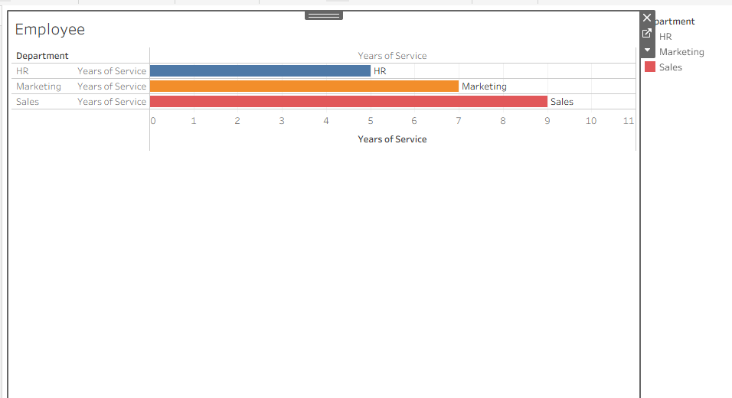

Result:
The Employee Performance Dashboard was successfully created in Tableau by combining the line chart and bar chart. The dashboard provides an interactive view of employee performance trends and department-wise employee distribution, allowing users to easily compare and explore employee data.

4.4

Algorithm
- Import the Product Inventory dataset into Tableau.
- Create a bar chart using Product Name and Quantity Available.
- Create a stacked bar chart using Product Category and Quantity Available, if Category data is available.
- Create a new Tableau Dashboard.
- Drag the bar chart and stacked bar chart onto the dashboard.
- Add filters such as Product or Category for interaction.
- Format the charts with suitable titles and labels.
- Test the dashboard by selecting different products or categories.
- Analyze the inventory levels using the interactive dashboard.
Output:
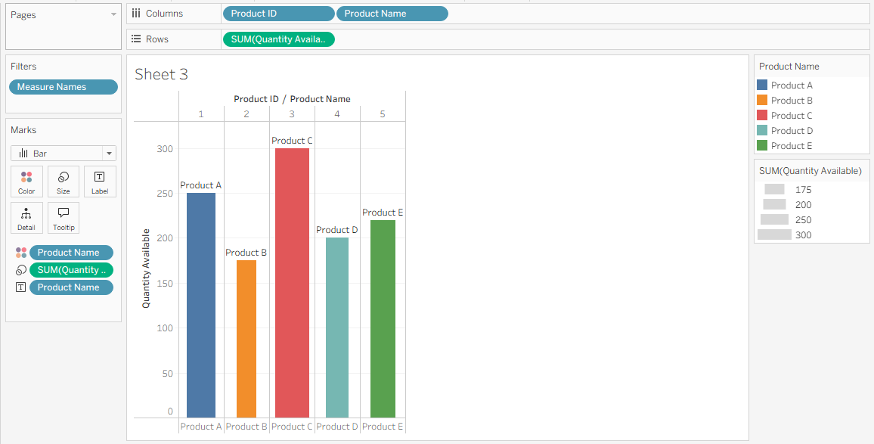

Result
The Product Inventory Management Dashboard was successfully created in Tableau using the available inventory data. Product C has the highest quantity (300), while Product B has the lowest quantity (175). The dashboard enables users to quickly compare inventory levels across products and, when category data is available, analyze category-wise inventory using the stacked bar chart.

5.4

Aim
To develop an interactive Website Analytics Dashboard in Tableau by combining a line chart of daily page views and a bar chart of click-through rates for easy exploration of website traffic data.

Algorithm
- Import the Website Traffic dataset into Tableau.
- Create a Line Chart using Date and Page Views.
- Create a Bar Chart showing the Top N days based on Click-through Rate.
- Create a new Tableau Dashboard.
- Add the Line Chart and Bar Chart to the dashboard.
- Add suitable filters and labels for interactive exploration.
- Format the charts with appropriate titles, axis names, and data labels.
- Test the dashboard by selecting different dates or Top N values.

Output:
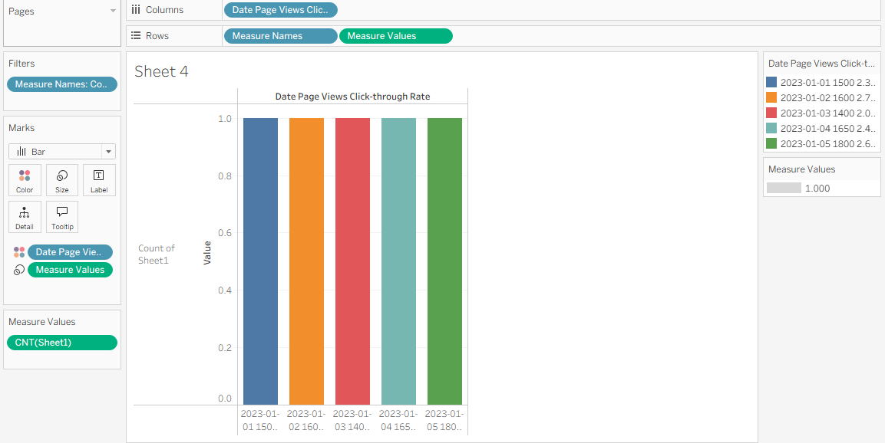

Result
The Website Analytics Dashboard was successfully created in Tableau. The line chart displays the daily page-view trend, while the bar chart identifies the days with the highest click-through rates. The dashboard provides an interactive way to compare website traffic and user engagement over the selected dates.

6.4

Aim
To develop an interactive Product Sales Analysis Dashboard in Tableau by combining a grouped bar chart, stacked area chart, and sales table for analyzing product sales over the first quarter.

Algorithm
- Import the Monthly Product Sales dataset into Tableau.
- Create a grouped bar chart for product-wise monthly sales.
- Create a stacked area chart showing the overall sales trend from January to March.
- Create a table showing monthly sales for each product.
- Create a new dashboard in Tableau.
- Add all three worksheets to the dashboard.
- Add filters for Product Name if required.
- Format the dashboard with titles, labels, and legends.
- Test the dashboard for interactive exploration.

Output:

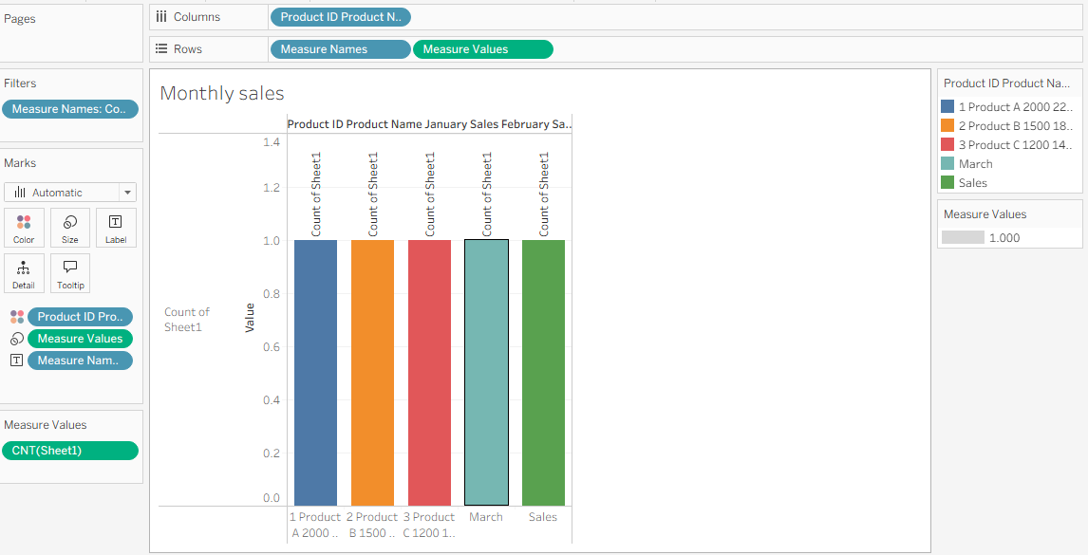

Result
The Product Sales Analysis Dashboard was successfully created in Tableau by combining the grouped bar chart, stacked area chart, and monthly sales table. The dashboard enables interactive comparison of product sales across January, February, and March.

7.4

Aim
To develop an interactive Customer Demographics Dashboard in Tableau by combining a bar chart, pie chart, and demographic table for easy analysis of customer information.

Algorithm
- Import the Customer Demographics dataset into Tableau.
- Create a bar chart showing the distribution of customer ages.
- Create a pie chart showing the distribution of customers by gender.
- Create a table displaying Customer ID, Age, Gender, and Income.
- Create a new dashboard.
- Add the bar chart, pie chart, and table to the dashboard.
- Add suitable titles, labels, and legends.
- Add filters if required for interactive exploration.
- Test the dashboard by selecting different demographic values.
Output:
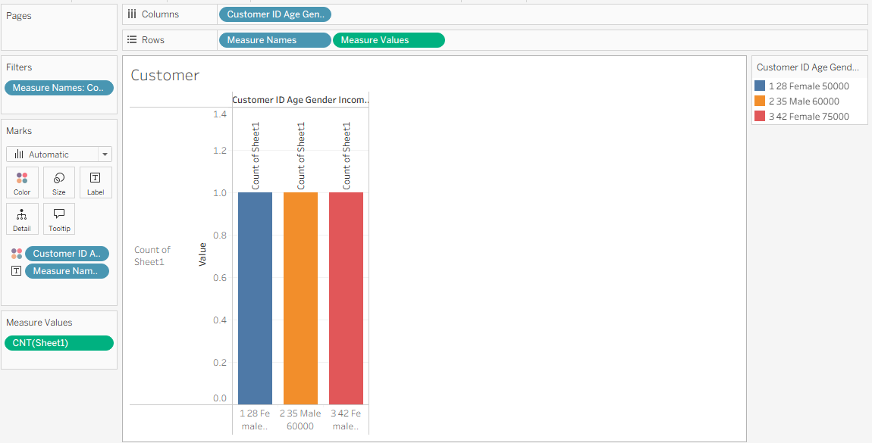

Result
The Customer Demographics Dashboard was successfully created by combining the bar chart, pie chart, and demographic table. The dashboard provides an interactive view of customer age, gender, and income, allowing users to easily explore and compare customer demographics.

8.4

Aim
To develop an interactive Employee Performance Dashboard in Tableau by combining a line chart, department-wise bar chart, and employee performance table.

Algorithm
- Import the Employee Performance dataset into Tableau.
- Create a line chart showing employee performance scores.
- Create a bar chart showing the number of employees in each department.
- Create a table displaying employee performance details.
- Create a new Tableau dashboard.
- Add the line chart, bar chart, and table to the dashboard.
- Add suitable titles, labels, and legends.
- Add filters for interactive exploration.
- Test the dashboard by selecting different departments.

Output:
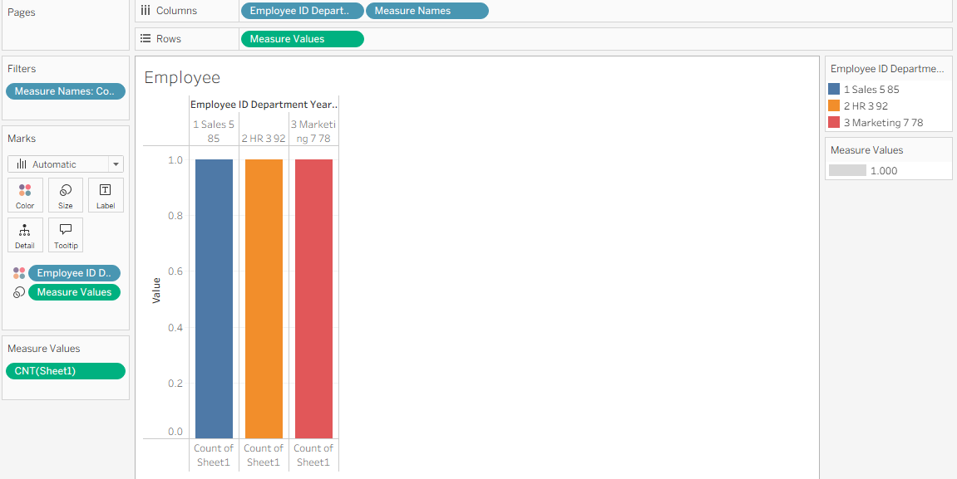

Result
The Employee Performance Dashboard was successfully created by combining the line chart, department-wise bar chart, and employee performance table. The dashboard enables users to interactively explore employee performance, years of service, and department-wise employee distribution in one view.

